

Machine Learning Foundations
Professor Prashanth L A
Department of Computer Science & Engineering,
Indian Institute of Technology, Madras
Least Squares and Projections onto a Subspace
Welcome to lecture 4 in week 3 of Machine Learning Foundations. In this lecture, we will be understanding projections in a more general context, which is projection onto a subspace, and we will also understand what this projection matrix that we make up, we will make up a projection matrix understand it by looking at what properties it satisfies and we will connect this to solving least squares problems.
(Refer Slide Time: 00:42)
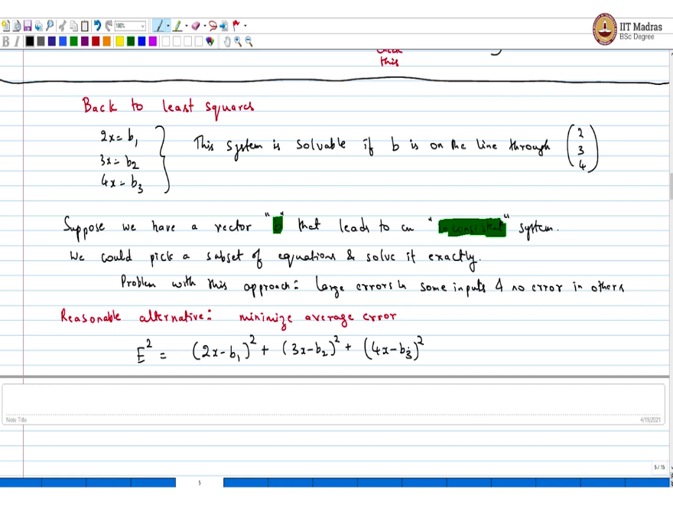
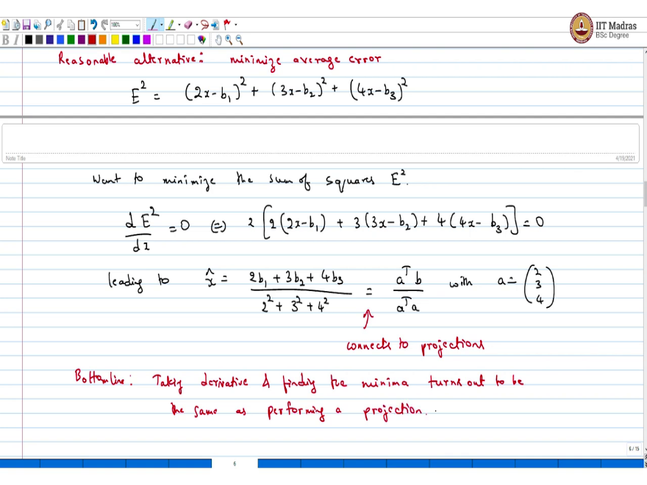
So, let us get back to the least squares problem, back least squares. So, recall the set of equations you had was like 2x equals b1, 3x equals b2, 4x equals b3. So, when is the system solvable? This system is solvable if b is on the line through 2, 3, 4, otherwise it is not solvable. Now, we are interested in the case where b is like, in many practical situations, you collect a large amount of data, there is noise in the data, and so it leads to inconsistent set of equations. In such situations, what will you do?
In such a situation, the best solution is least squares. Let us try to understand this. Suppose we have a vector b that leads to an inconsistent system. Now, what would be a reasonable alternative? Before that, we could pick a subset of equations and solve it exactly.
But what is the problem with this? The problem with this approach, what would happen is you would have large errors in some inputs and no error in others, which is like simply because you discarded a few inputs, so you discarded some input data. And that would lead to large error in, I mean, that could lead to possibly large error in the data that you discarded. Well, whatever subset you pick may be perfectly solvable. So, it would have no error.
Now, what would be a reasonable alternative? A reasonable, hence the reasonable alternative is minimize the average error. So, in this particular example, what is the average error? Let me write it as E. The average error is a sum of squares and you want to find the least squares, so 2x - b1 square + 3x - b2 square + 4x - b3 square, hence the name least squares, because you want to minimize this sum of squares.
So, what is the straightforward way? This is something that you must have done in your high school or even little later. We will just take the derivative of this with respect to x and equate it to 0, which is the same 2 ×, I mean, you can discard the 2, 2x - b1 + 3 into 3x - b2 + 4 into 4x - b3 this is equal to 0. Now, this leading to the following least square solution, x hat equals 2b1 + 3b2 + 4b3 divided by 2 square + 3 square + 4 square.
Now, this is somewhat strikingly is similar. This is like a transpose b divided by a transpose a with a equals 2, 3, 4. And this is where the connection to, this is where it connects to projections. So, pause and think about it. When we took the derivative, which is just employing calculus and the found optima, the optimal solution turned out to be the same as something that I would obtain through projection. So, the bottom line is taking derivative and finding the minima turns out to be the same as performing a projection. So, that is really the bottom line.
So, solving a least squares problem, either you could take the calculus route, take the derivatives or you could take the alternative route which is to project. Write down a system of equations, look at its columns, project onto the column space. Right now we have not really looked at or discussed how to perform projections onto the column space. We have restricted our attention to projection onto a line.
(Refer Slide Time: 07:57)
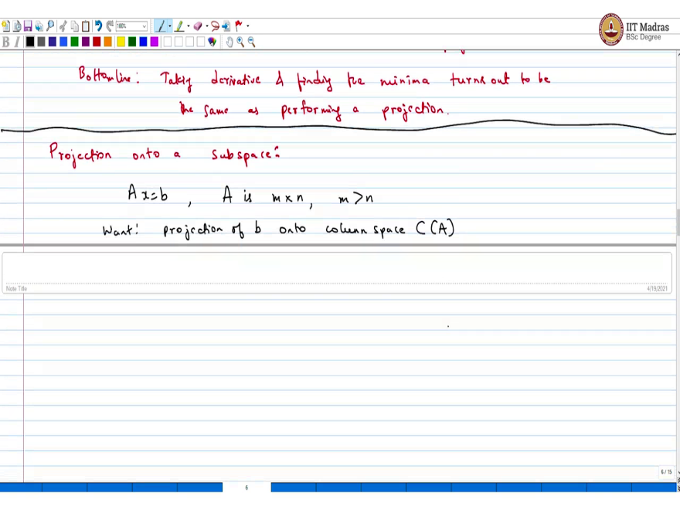
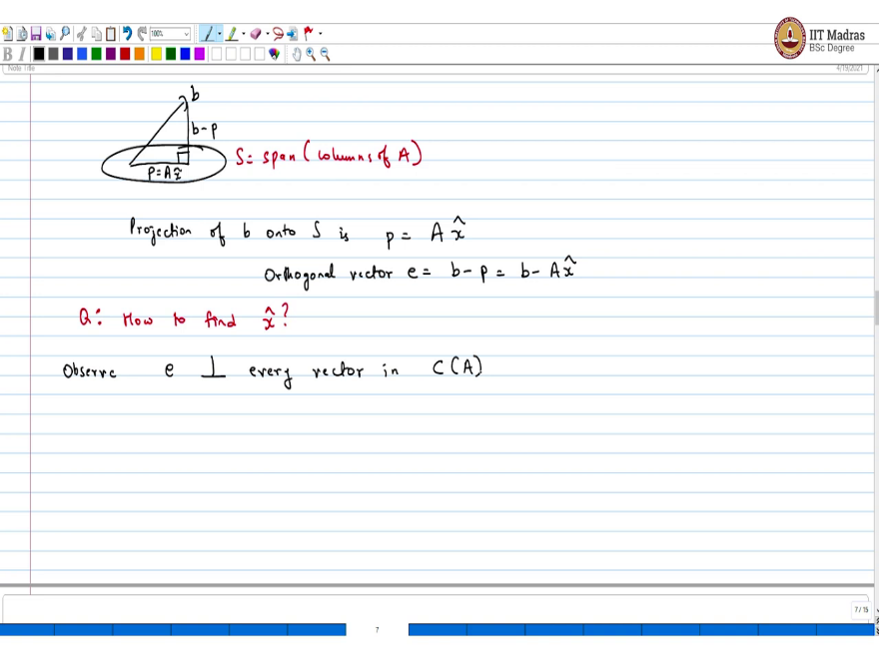
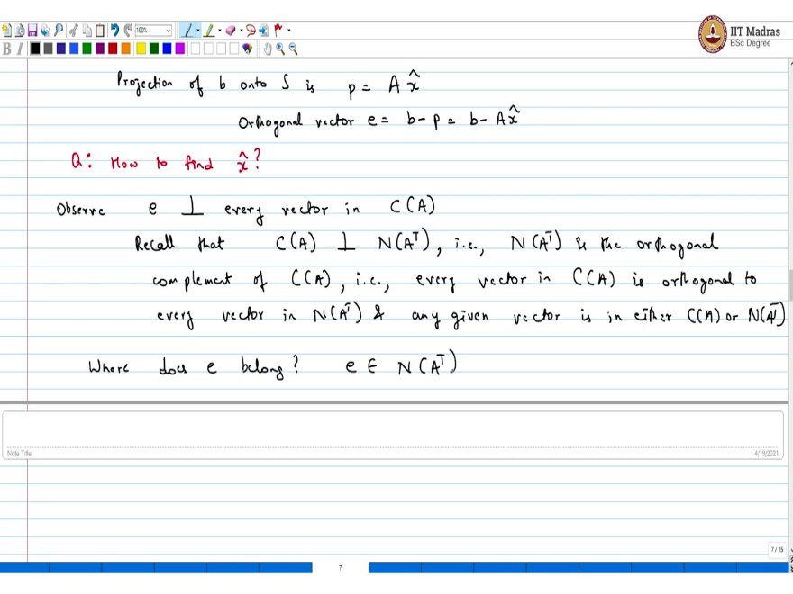
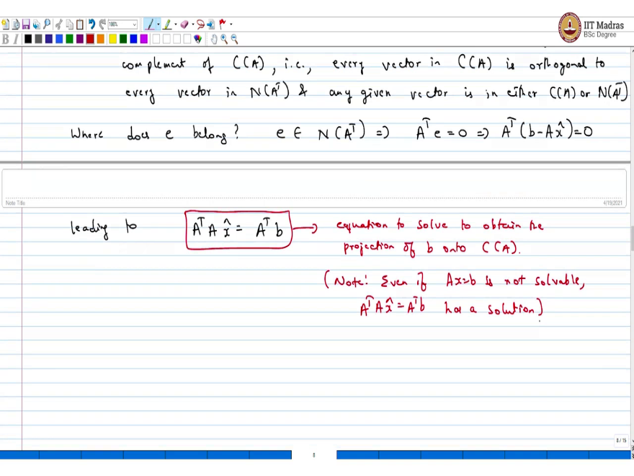
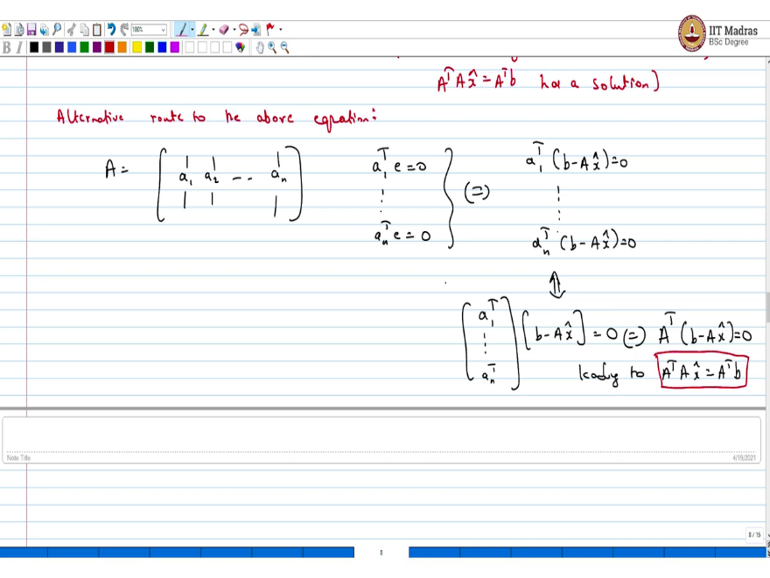
So, the very next topic that we are going to look at is projection onto a subspace. So, what I mean by this. I have system this A is m $×$ n. Let us say I have more equations than unknowns. And I want to project onto the column space of A. Want projection of b onto column space of A. So, this is what we are going to do and let us do this. So, the logic is going to be the same.
So, let us, I mean, whatever we did in the case of line, so you have a b, and then imagine this is your set, say s is the span of columns of A. So, this is the set and you want to do orthogonal projection onto this. Let me call this p. In this case P would be Ax hat, and this would be your b - p. So, the projection of b on to s is p equals some Ax hat and the orthogonal vector e is b - p, which is b - Ax hat. So, p is going to be in the span of, so it is some A × some x hat.
Now, the question is, I want to figure what the x hat is. So, the question is, how to find x hat which is equivalent to finding, I mean, once I have x hat, I know the projection of the vector b. So, we will start with an observation. Observe e is orthogonal to every vector in column space of A. Also you recall from the, one of the earlier lectures, that column space of A is orthogonal to null space of A transpose and these are orthogonal complements.
And to put differently, that is null space of A transpose is the orthogonal complement of column space of A, which is equivalent to saying that, that is column space, that is every vector in column space of A is orthogonal to every vector in null space of A transpose and any given vector is in either C of A or null space of A transpose. So, that is the orthogonal complement part.
So, the complement part is that, the complete the space. So, either a vector is in the column space of A or it is in the null space of A transpose. Given this, where can e belong? So, the question is, where does e belong? The answer is, it is orthogonal to every vector in column space of A. So, e belongs to null space of A transpose. That is all there is true.
Which is like saying, when a vector belongs to the null space of A transpose, that is like saying A transpose into that vector e equals 0, which is equivalent to saying A transpose into b - Ax hat equals 0, leading to the most important equation, which is A transpose Ax hat equals A transpose b. This is the most important equation. So, this is the equation to solve, to obtain the projection of b onto column space of A.
Note, even if Ax equals b is not solvable, which is like saying it is inconsistent, A transpose Ax hat equals A transpose b has a solution. So, even if you start with the inconsistent set of equations, you will end up with this. Now, this, if this passage was not clear about orthogonal complements, there is a more say first principles way of figuring this equation.
Alternative route to the above equation, so let us say the matrix A to start with this, these composed of columns a1, a2, until an, it is a m × n matrix. And now we know that column, e is orthogonal to each one of them. So, you have a1 transpose e equals 0, blah, blah, an transpose e equals 0, because e is orthogonal to all of them. This is equivalent to writing a1 transpose b - Ax hat equals 0 dot, dot, dot, an transpose b - Ax hat equals 0.
Now, this is equivalent to writing it in simple notation a1 transpose until an transpose b - Ax hat equals 0. Now, this final thing is the same as A transpose b - Ax hat equals 0, leading to A transpose Ax hat equals A transpose b.
So, the only fact that we used was this vector e which is b - p was orthogonal to the space where you are projecting. Once you use that you can arrive at this either through the orthogonal complement route which is one shot or you can do a first principles by looking at the matrix A and its columns. Hope this is clear.
(Refer Slide Time: 16:10)
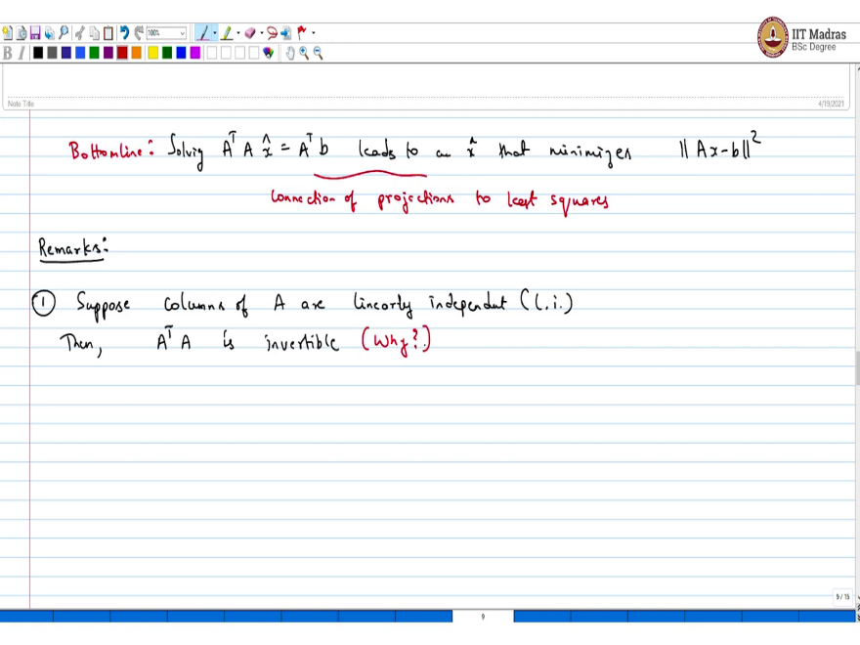
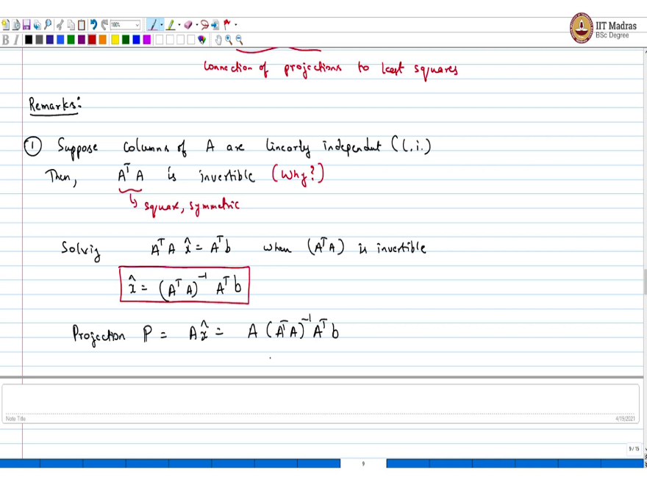
So, the bottom line is, and that is the very first line, the bottom line is A transpose Ax hat equals solving leads to an x hat that minimizes least squares error, that minimize the error Ax - b square. This is really the connection between, this is the connection of projections to least squares. So, if you want to solve a least squares problem that is like norm Ax - b square if you want to minimize, then all you have to do is project onto the column space of A which is equivalent to solving A transpose Ax hat equals A transpose b.
Now, some remarks, very first, suppose columns of A are linearly independent, let us say I just use the short form l dot i dot, then A transpose A is invertible. I am going to just leave with why. This is linear algebra one on one you can figure. If I have a matrix whose columns are linearly independent then A transpose A will be invertible. It will be full rank. So, you have a full rank matrix and then you do A transpose A. A transpose A is a square matrix. And the question is why is that invertible, you can argue this. A transpose A is a square matrix also it is symmetric.
Now, so coming back to this famous equation, let me call this famous equation A transpose Ax hat equals A transpose b. When A transpose A is invertible, what you can do is, so only when A transpose A is invertible you can solve this. This is x hat. So, the projection is, I have to multiply A again, because projection is Ax hat if you want, let me write this. Ax hat so A × A transpose A inverse A transpose b. So, that is your projection matrix. That is your first remark.
(Refer Slide Time: 20:06)
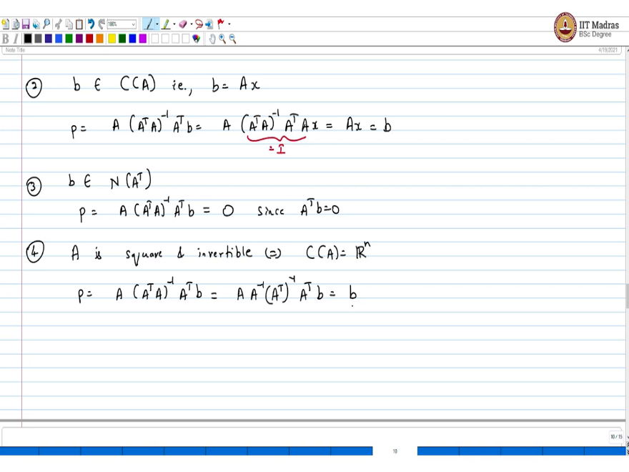
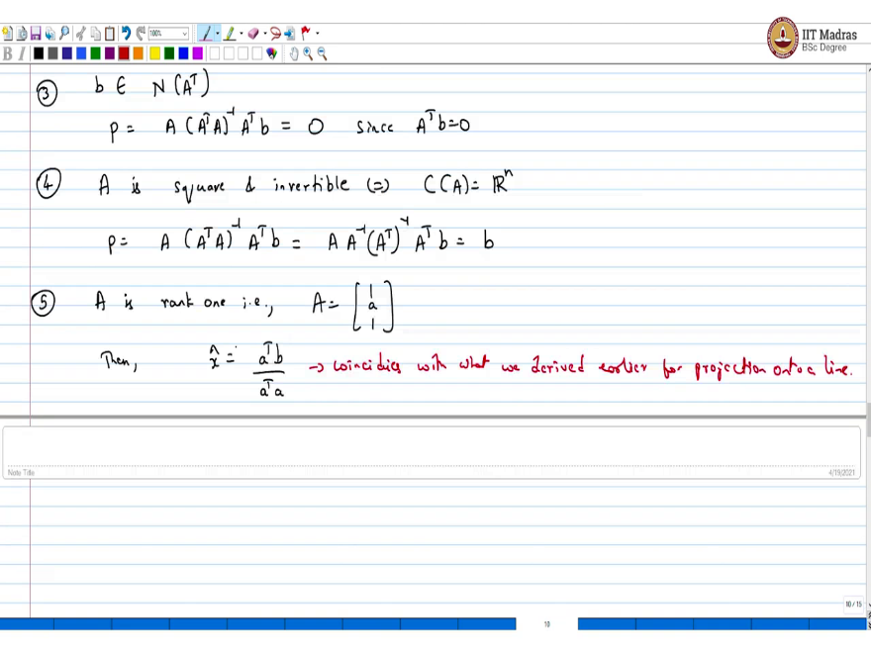
Let us look at some other special cases, simple special cases. Suppose b belongs to the column space of A, then that is b equal some A × x. In this case, if I project, which is multiply by p, what should I recover. I can think about this. The idea is you already in the column space of A, so if I project, I should not change the vector at all. I should recover b and that is what happens. So, the projection p is A × A transpose A inverse A transpose into b is the same as A into A transpose A inverse A transpose Ax, but this is nothing but, you can just look at this, just Ax, because this part in between which is this calls identity. So, you get, but Ax is the same as b.
Now, let us look at the other complementary case. Suppose b belongs to null space of A transpose, which is like saying that it is in the orthogonal complement, then what happens is p equals A into A transpose A inverse A transpose b, but that is just 0 since A transpose b equals 0. And this last part A transpose b equals 0 is simply because p is in the null space of that matrix, A transpose.
Last thing is imagine A is a square matrix and invertible which is equivalent to saying what is the column space of A, it is Rn. So, what would be the projection? It would be A into A transpose A inverse A transpose b. I mean, if I take any b, is it in the column space of this matrix, simply because the columns spanned the entire space.
So, every b is there. So, what should I recover here, whenever I project using this matrix, I should recover b. And that is what happens. Because A is invertible I can take the inverse inside this A transpose A inverse, so I would get A inverse A transpose inverse A transpose b, which is nothing but b.
The last thing is imagine A is rank one that is A is just one column with vector A. Then, if you apply this formula, then you get x hat equals a transpose b divided by a transpose a. And this coincides with what we derived earlier for projection onto a line. So, moving on, so we got the projection matrix. We know how to project onto a subspace.
(Refer Slide Time: 24:07)
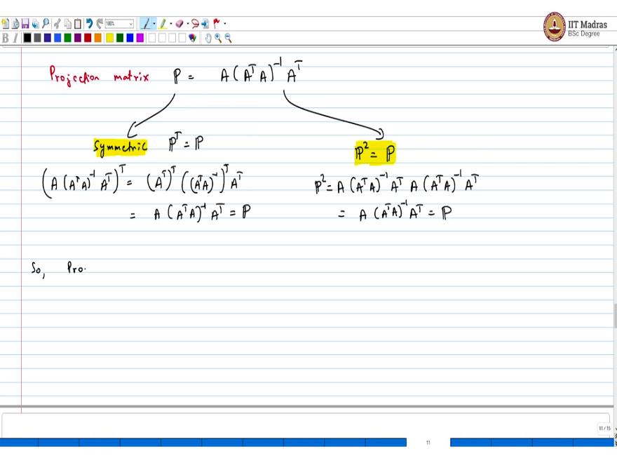
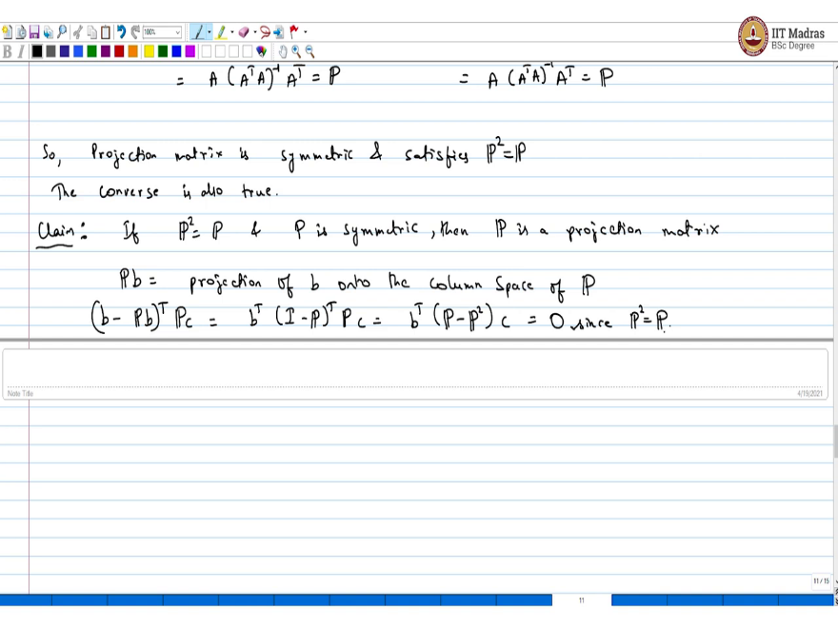
The next thing we are going to look at is we will still understand this projection matrix a little more, which is like saying that you know the projection matrix P is A into A transpose A inverse into A transpose. The first thing you have to observe is it is symmetric. This can be checked. One would symmetric that is P transpose equals P this can be check.
Just take the transpose of this entire thing A into A transpose A inverse A transpose whole transpose this is equals A transpose whole transpose and A transpose A inverse transpose into A transpose. This is equal to A into A transpose A. The point is A transpose A is symmetric matrix so its transpose is going to be itself. Then you left with A transpose this is nothing but P.
The second thing is, you can check is, so we had symmetric, the second thing that it is going to satisfies, P square equals P. Now, this again can be checked. So, you just do A into A transpose A inverse A transpose, again, A into A transpose A inverse A transpose and you will just observe that this is nothing but A into A transpose A inverse A transpose which is the same as P, P square equals P.
So, what we have is projection matrix is symmetric and satisfies P square equals P. The converse is also true. That is the claim is if P square equals P and P is symmetric, then P is a projection matrix. That is the converse.
In this case, what is Pb? Pb is the projection of b onto the column space of P. The case when we saw before the column space of P is just in the previous case, when we constructed this column space of b is column space of A. But in the corners case, when you start with any P square equals P, then this can be easily seen.
I mean, for example, if you want to see this short one line proof is here, you take b - Pb and take its start product with any c, then this is the same as b transpose I - P transpose Pc. This is equals b transpose into P - P square into c. But P square equals P. So, that is where the claim ends. So, equals 0 since P square equals P. So, that is where the discussion about projections ends. We will just look at an example of least squares and try to understand it and close this discussion about least squares.
A summary of this lecture before we end, in this lecture, what we looked at was, in a simple, we started with a one dimensional example for least squares. And what we did was, we took the calculus route, which is to take derivatives and find the optima for a least squares problem, which is solving a linear system of equations.
And we saw that that has strong connections to projections, because the solution that we got ties in well with the projection onto a line. Now we try to, and the next logical step that we took was to generalize this to the multi-dimensional case. And here we understood how we project on to a subspace and we use this to understand how to project onto a column space of a matrix, say A.
Now, where does this play a role? This plays a role in understanding how to solve, how to approximately solve a system of equations Ax equals b in the case where it is inconsistent, where b is not in the column space of A. In this case, what you can do is you can use projections to make up a system of equation, a linear system of equations, which is always soluble. Even if Ax equals b is not solvable, even if Ax equals b is inconsistent, we are able to make up a system of equations which can be solved and this system of equations we made up using the idea of projection onto the column space of A.
And now the matrix underlying this system of equations is a projection matrix. And this projection matrix we found that it satisfies two properties; one is that it is symmetric; and the second thing is if I square that matrix, I recover the original matrix which is like if I call P as the projection matrix, then P transpose equals P and also P square equals P.
And so, we made up a projection matrix which satisfies these two properties. And interestingly, the converse is also true, which is like saying that if I have a matrix, which says symmetric and satisfies P square equals P, then it is a projection matrix, which is like it is projecting onto the column space of a certain matrix and that can be, that is what we understood.
And we also looked at some special cases where, to understand the equation that we made up, that led up to the, for solving least squares, that equation we understood special cases where the case where A is invertible and things like that and vectors, if I have a vector which is in the column space of that matrix what happens and when I apply this operator, projection operator and what happens to a vector which is in the null space and things like that, very simple cases. And also the case when A is full column rank leads to a particular simple situation where Ax equals b is always solvable.
In the subsequent lecture, we will look at simple least squares example and we will solve the system of equations that we made using projections to solve the least squares problems. We learn through example in the next lecture.

